Forecasting in Multiple Linear Regression Using Statgraphics

For the Securicorp example, the following represents the variables in a multiple regression model:
- Sales: Sales, in thousands of dollars
- Ad: Advertising, in hundreds of dollars
- Bonus: Bonuses, in hundreds of dollars
- West: The Western sales territory dummy variable
- Midwest: the Midwestern sales territory dummy variable
- (Note: The Southern sales territory does not receive a dummy variable in this model)

The resulting model produced by StatGraphics is

To produce point estimates and prediction and confidence interval from the model in StatGraphics, check Reports in the Tables and Graphs menu. Now, suppose we wish to forecast sales in the Western region for $50,000 in advertizing and $30,000 in Bonuses. Place the appropriate values in the first empty row (row number 26) of the spreadsheet, as shown below.

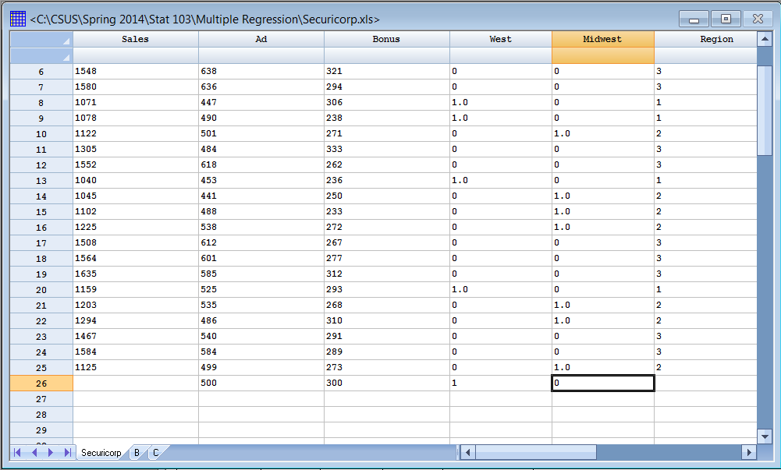

In the Reports window you will see the output below showing the point estimate (Fitted Value), Prediction Interval (Lower and Upper CL for Forecast), and Confidence Interval (Lower and Upper CL for Mean ). The default level of 95% for the intervals can be changed by right-clicking in the Reports window and selecting Pane Options.

